For Immediate Release Contact: Office of Communications
September 21, 2025 312-745-6110

Offender Charged with Aggravated Battery of 22-Year-Old Female & 62-Year-Old Male

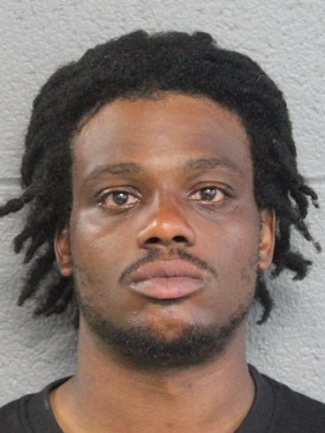

Offender: Shaquille Rogers, 32
1000 block of N. Lockwood Ave.
Chicago, Illinois

Charges: One (1) felony count – Aggravated battery/Use Deadly Weapon
One (1) felony count – Aggravated battery/Public Place
One (1) misdemeanor count – Battery - Cause Bodily Harm

Court: Detention Hearing – 2600 S. California – September 22, 2025

Narrative: The above offender was arrested by members of the Chicago Police Department on September 20, 2025, in the 1800 block of S. Kedzie Ave., at approximately 10:25 a.m. He was identified as the offender who, less than 20 minutes earlier, stabbed and seriously injured a 22-year-old female in the 1200 block of S. Spaulding Ave. The above offender also stabbed and seriously injured a 62-year-old male in the 1200 block of S. Kedzie Ave. minutes later (10th District). The offender was placed into custody and charged accordingly. No additional information is available at this time.

# # #

